Design Plan: | Document Name: Interface Design Document | SWD/Form No.5
Effective Date | Version :1 | Page No.1

- Form name: UserManager
- Description: UserManager

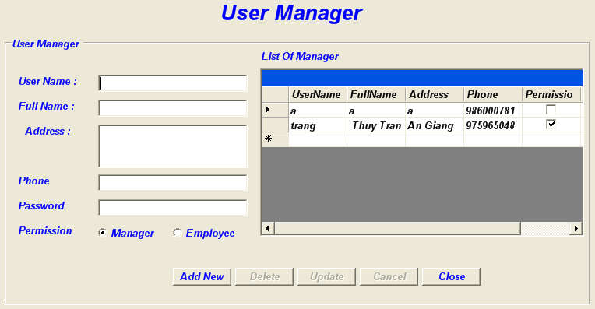

- Control on form:

No | Control | Type | Default Value | Description
1 | lbl_title | Label | User Manager
2 | grp_UserManager | GroupBox | User Manager
3 | lbl_UserName | Label | User Name
4 | lbl_FullName | Label | Full Name
5 | lbl_Address | Label | Address
6 | lbl_Phone | Label | Phone
7 | lbl_Pass | Label | Password
8 | lbl_Per | Label | Permission
9 | lbl_List | Label | List of Manager
10 | btn_AddNew | Button | AddNew
11 | btn_Delete | Button | Delete
12 | btn_Update | Button | Update
13 | btn_Cancel | Button | Cancel
14 | btn_Close | Button | Close
15 | dbg_List | DataGrid | Load data
16 | txt_UserName | TextBox | Null
17 | txt_FullName | TextBox | Null
18 | txt_Address | TextBox | Null
19 | txt_Phone | TextBox | Null
20 | txt_Pass | TextBox | Null
21 | rad_Manager | RadioButton | Checked
22 | rad_Employee | RadioButton | Null

- Form name: SearchRoom
- Description: SearchRoom

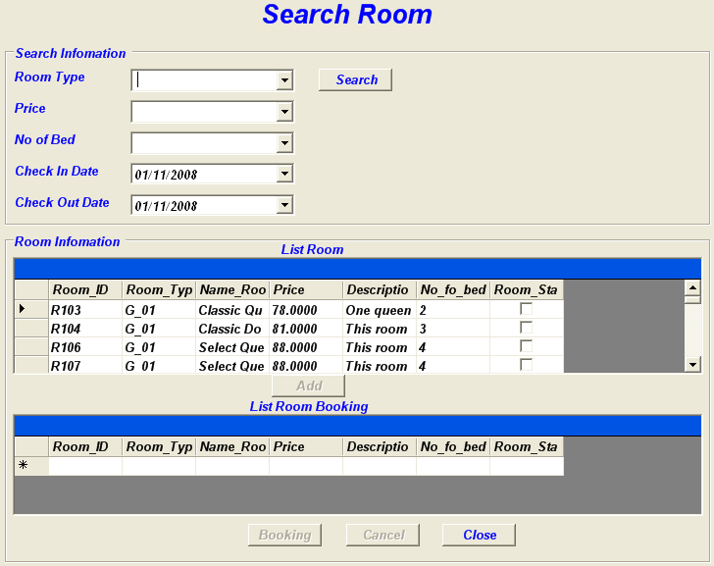

- Control on form:

No | Control | Type | Default Value | Description
1 | grp_searchinfomation | GroupBox | Search Information
2 | grp_Room | GroupBox | Room Information
3 | lbl_title | Label | Search Room
4 | lbl_roomtype | Label | Room Type
5 | lbl_price | Label | Price
6 | lbl_noofbed | Label | No of Bed
7 | lbl_checkindate | Label | Check In Date
8 | lbl_checkoutdate | Label | Check Out Date
9 | lbl_listRoom | Label | List Room
10 | lbl_listBookingRoom | Label | List Room Booking
11 | cbo_roomtype | ComboBox
12 | cbo_price | ComboBox
13 | cbo_noofbed | ComboBox
14 | dtp_checkindate | DateTimePicker | Check in Date | dd/MM/yyyy
15 | dtp_checkoutdate | DateTimePicker | Current day | dd/MM/yyyy
16 | btn_Search | Button | Search
17 | btn_Add | Button | Add
18 | btn_booking | Button | Booking
19 | btn_cancel | Button | Cancel
20 | btn_close | Button | Close
21 | dbg_ListRoom | DataGrid | Load data
22 | dbg_ListRoomBooking | DataGrid | Load data when the Add click

- Form name: CheckOut
- Description: CheckOut

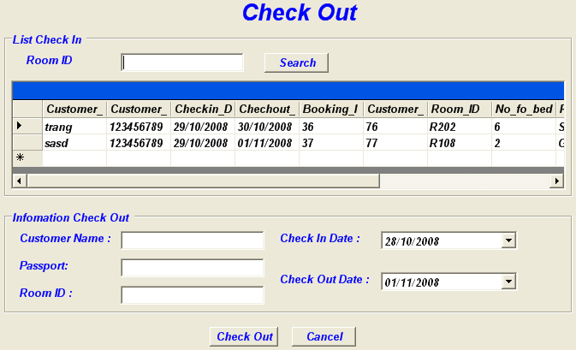

- Control on form:
No | Control | Type | Default Value | Description
1 | grp_List | GroupBox | List Check In
2 | grp_Info | GroupBox | Information Check Out
3 | lbl_Title | Label | Check Out
4 | lbl_RoomID1 | Label | Room ID
5 | lbl_Customer | Label | Customer Name
6 | lbl_Passpor | Label | Passpor
7 | lbl_RoomID2 | Label | Room ID
8 | lbl_Checkindate | Label | Check In Date
9 | lbl_Checkoutdate | Label | Check Out Date
10 | txt_RoomID1 | TextBox
11 | txt_Customer | TextBox
12 | txt_Passpor | TextBox
13 | txt_RoomID2 | TextBox
14 | dtp_Checkindate | DateTimePicker | Check in Date | dd/MM/yyyy
15 | dtp_Checkoutdate | DateTimePicker | Current day | dd/MM/yyyy
16 | btn_Search | Button | Search
17 | btn_ChekOut | Button | Check Out
18 | btn_Cancel | Button | Cancel
19 | dbg_List | DataGrid | Load data

- Form name: CheckIn
- Description: CheckIn

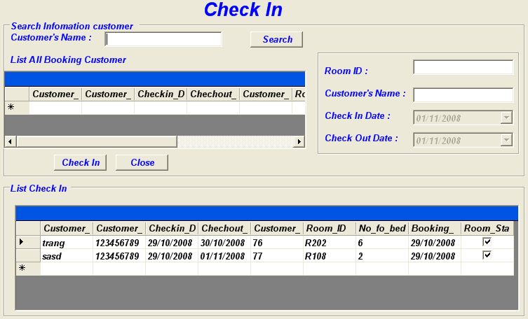

- Control on form:

No | Control | Type | Default Value | Description
1 | grp_SearchInfomationCustomer | GroupBox | Search Information customer
2 | grp_ListCheckIn | GroupBox | List Check In
3 | Grp_Info | GroupBox
4 | lbl_TitleCheckIn | Label | Check In
5 | lbl_CustomerName | Label | Customer’s Name
6 | lbl_RoomID | Label | Room ID
7 | lbl_CustomerNameSearch | Label | Customer’s Name
8 | lbl_CheckInDate | Label | Check In Date
9 | lbl_CheckOutDate | Label | Check Out Date
10 | lbl_ListAllBooking | List All Booking Customer
11 | txt_CustomerName | Textbox
12 | txt_RoomID | Textbox
13 | txt_CustomerNameSearch | Textbox
14 | dtp_CheckInDate | DateTimePicker | Check In Date, Enabled(false)
15 | dtp_CheckOutDate | DateTimePicker | Current day, Enabled(false)
16 | btn_Search | Button | Search
17 | btn_CheckIn | Button | Check In
18 | btn_Close | Button | Close
19 | dbg_ListRoomBookingCustomer | DataGrid | Load Data
20 | dbg_ListCheckIn | DataGrid | Load data when the Check In click

- Form name: ChangeRoom
- Description: ChangeRoom

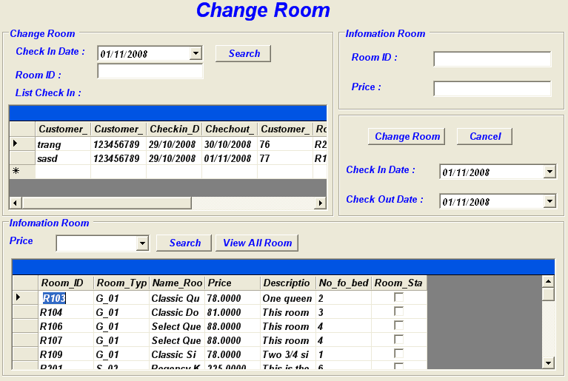

- Control on form:

No | Control | Type | Default Value | Description
1 | grp_ChangRoom | GroupBox | Change Room
2 | grp_InfomationRoom | GroupBox | Information Room
3 | grp_RoomInfomation | GroupBox | Information List Room
4 | grp_Button | GroupBox | Null
5 | dbg_ListCheckIn | DataGrid | Load data
6 | dbg_RoomInfomation | DataGrid | Load data
7 | lbl_TitleChangeroom | Label | Change Room
8 | lbl_SearchCheckInDate | Label | Check In Date
9 | lbl_SearchRoomID | Label | Room ID
10 | lbl_RoomID | Label | Room ID
11 | lbl_Price | Label | Price
12 | lbl_CheckInDate | Label | Check In Date
13 | lbl_CheckOutDate | Label | Current day
14 | lbl_PriceSearchRoom | Label | Price
15 | cbo_Price | ComboBox
16 | txt_SearchRoomID | TextBox | Null
17 | txt_RoomID | TextBox | Null
18 | txt_Price | TextBox | Null
19 | dtp_SearchCheckInDate | DateTimePicker | Check In Date | dd/MM/yyyy
20 | dtp_CheckInDate | DateTimePicker | Check In Date | dd/MM/yyyy
21 | dtp_CheckOutDate | DateTimePicker | Current day | dd/MM/yyyy
22 | btn_SearchRoom | Button | Search
23 | btn_SearListRoom | Button | Search
24 | btn_ChangeRoom | Button | Change Room
25 | btn_Cancel | Button | Cancel
26 | btn_ViewAllRoom | Button | View All Room

- Form name: BufferOrder
- Description: BufferOrder

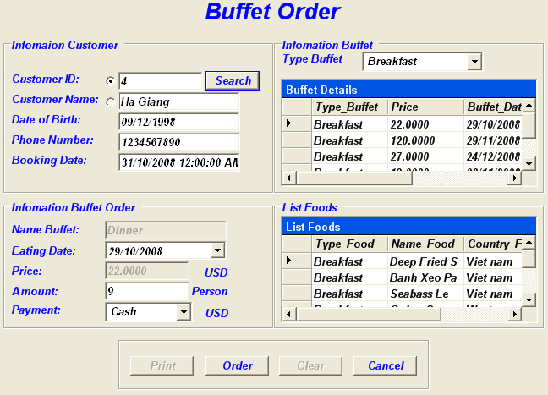

- Control on form:

No | Control | Type | Default Value | Description
1 | grp_customer | GroupBox | Information Customer
2 | grp_buffet | GroupBox | Information Buffet
3 | grp_order | GroupBox | Information Buffet Order
4 | grp_Listfood | GroupBox | ListFoods
5 | dbg_Listtype | DataGrid | Load data
6 | dbg_Listfood | DataGrid | Load data
7 | lbl_buffetorder | Label | Buffet Order
8 | lbl_customerName | Label | Customer Name
9 | lbl_CustomerID | Label | CustomerID
10 | lbl_Birth | Label | Date of Birth
11 | lbl_Price | Label | Price
12 | lbl_Phone | Label | Phone Number
13 | lbl_BookingDate | Label | Booking Date
14 | lbl_Namebuffer | Label | Name Buffet
15 | lbl_eatingdate | Label | Eating Date
16 | lbl_quantity | Label | Amount
17 | lbl_Payment | Label | Payment
18 | lbl_typebuffet | Label | Type Buffet
20 | lbl_USD | Label | USD
21 | lbl_Person | Label | Person
22 | Lbl_USDpay | Label | USD
23 | txt_cust_ID | TextBox
24 | txt_cust_name | TextBox
25 | txt_Price | TextBox | Enabled(False)
26 | txt_cus_birth | TextBox
27 | txt_cust_phone | TextBox
28 | txt_booking_date | TextBox
29 | txt_buffetname | TextBox | Enabled(False)
30 | txt_amount | TextBox
31 | dtp_Eatingdate | DateTimePicker | Eating Date | dd/MM/yyyy
32 | cbo_pay | ComboBox
33 | cbo_type | ComboBox
34 | btn_Search | Button | Search
35 | btn_Order | Button | Order
36 | btn_Cancel | Button | Cancel
37 | btn_Clear | Button | Clear
38 | grp_Button | GroupBox | Null

- Form name: BufferManager
- Description: BufferManager

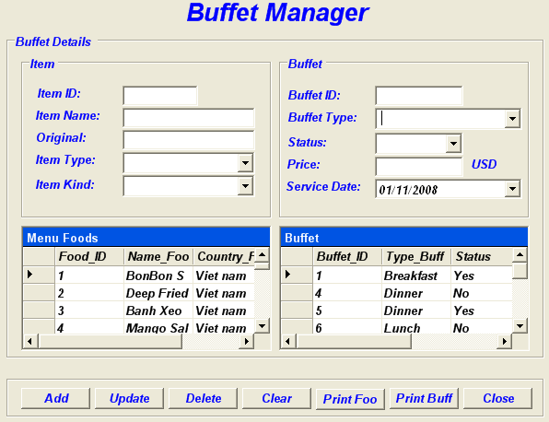

- Control on form:

No | Control | Type | Default Value | Description
1 | grp_bufferdetail | GroupBox | Buffet Details
2 | grp_Item | GroupBox | Item
3 | grp_buffet | GroupBox | Buffet
4 | grp_Button | GroupBox
5 | dbg_MenuFoods | DataGrid | Load data
6 | dbg_Buffet | DataGrid | Load data
7 | lbl_buffetmanager | Label | Buffet Manager
8 | lbl_itemID | Label | Item ID
9 | lbl_itemName | Label | Item Name
10 | lbl_Original | Label | Original
11 | lbl_price | Label | Price
12 | lbl_itemtype | Label | Type
13 | lbl_itemkind | Label | Kind
14 | lbl_buffetType | Label | BuffetType
15 | lbl_buffetID | Label | Buffet ID
16 | lbl_status | Label | Status
17 | lbl_serviceDate | Label | Service Date
18 | lbl_USD | Label | USD
19 | txt_id | TextBox | Null
20 | txt_iname | TextBox | Null
21 | txt_origin | TextBox | Null
22 | txt_price | TextBox | Null
23 | txt_buf_id | TextBox | Null
24 | cbo_buf_type | ComboBox
25 | cbo_status | ComboBox
26 | cbo_type | ComboBox
27 | cbo_kind | ComboBox
28 | btn_Add | Button | Add
29 | btn_Update | Button | Update
30 | btn_Delete | Button | Delete
31 | btn_Clear | Button | Clear
32 | btn_Close | Button | Close
33 | dtp_servicedate | DateTimePicker | Service Date

- Form name: BookingRoom
- Description: BookingRoom

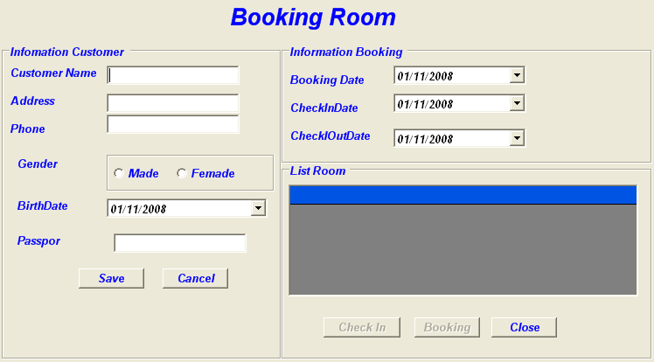

- Control on form:

No | Control | Type | Default Value | Description
1 | grp_customer | GroupBox | Information Customer
2 | grp_booking | GroupBox | Information Booking
3 | grp_sex | GroupBox
4 | grp_listroom | GroupBox | List Room
5 | dbg_ListRoom | DataGrid | Load data
6 | lbl_title | Label | Booking Room
7 | lbl_customer | Label | Customer Name
8 | lbl_address | Label | Address
9 | lbl_phone | Label | Phone
10 | lbl_gender | Label | Gender
11 | lbl_checkindate | Label | CheckInDate
12 | lbl_checkoutdate | Label | CheckOutDate
13 | lbl_bookingdate | Label | Booking Date
14 | lbl_birthdate | Label | Birth Date
15 | lbl_passpor | Label | Passpor
16 | txt_Address | TextBox | Null
17 | txt_Phone | TextBox | Null
18 | txt_Passpor | TextBox | Null
19 | txt_Customer | TextBox | Null
20 | dtp_Checkindate | DateTimePicker | Check In Date | dd/MM/yyyy
21 | dtp_Birthdate | DateTimePicker | Birth Date | dd/MM/yyyy
22 | dtp_Checkoutdate | DateTimePicker | Current day | dd/MM/yyyy
23 | dtp_Bookingdate | DateTimePicker | Booking Date | dd/MM/yyyy
24 | btn_Save | Button | Save
25 | btn_Booking | Button | Booking
26 | btn_Cancel | Button | Cancel
27 | btn_Close | Button | Close
28 | btn_CheckIn | Button | Check In
29 | rad_male | RadioButton | Male
30 | rad_female | RadioButton | Female

- Form name: BookingBuffet
- Description: BookingBuffet

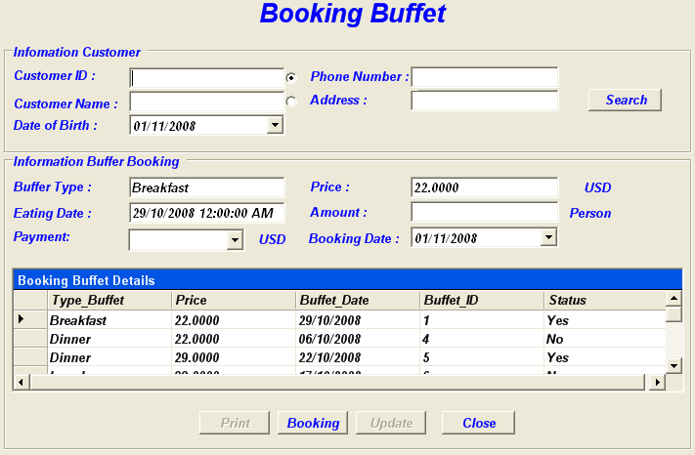

- Control on form:

No | Control | Type | Default Value | Description
1 | grp_Customer | GroupBox | Information Customer
2 | grp_Buffet | GroupBox | Information Buffet Booking
3 | dbg_List | DataGrid | Load data
4 | lbl_title | Label | Booking Buffet
5 | lbl_Customer | Label | Customer Name
6 | lbl_CustomerID | Label | Custome ID
7 | lbl_Birth | Label | Date of Birth
8 | lbl_Phone | Label | Phone Number
9 | lbl_Address | Label | Address
10 | lbl_Buffettype | Label | Buffet Type
11 | lbl_EatingDate | Label | Eating Date
12 | lbl_Payment | Label | Payment
13 | lbl_Bookingdate | Label | Booking Date
14 | lbl_Price | Label | Price
15 | lbl_Amount | Label | Amount
16 | lbl_USD | Label | USD
17 | lbl_USDpay | Label | USD
18 | lbl_Person | Label | Person
19 | txt_cust_ID | TextBox | Null
20 | txt_cust_name | TextBox | Null
21 | txt_cust_phone | TextBox | Null
22 | txt_cust_add | TextBox | Null
23 | txt_buff_type | TextBox | Null
24 | txt_eat_date | TextBox | Null
25 | txt_price | TextBox | Null
26 | txt_amount | TextBox | Null
27 | cbo_pay | ComboBox
28 | dtp_Bookingdate | DateTimePicker | Booking Date | dd/MM/yyyy
29 | btn_Search | Button | Search
30 | btn_Booking | Button | Booking
31 | btn_Close | Button | Close
32 | btn_Update | Button | Update

- Form name: BillRoom
- Description: BillRoom
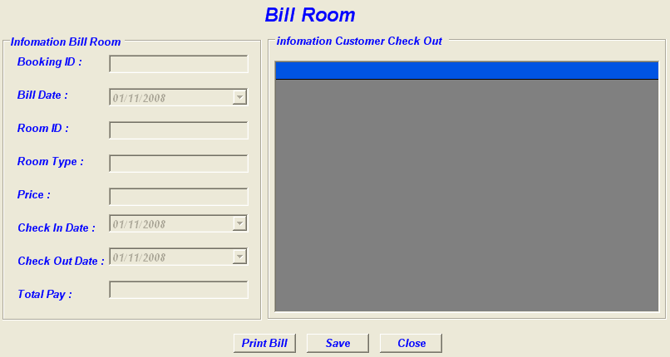

- Control on form:

No | Control | Type | Default Value | Description
1 | grp_billroom | GroupBox | Information Bill Room
2 | grp_Customer | GroupBox | Information Customer Check Out
3 | dbg_customer | DataGrid | Load data
4 | lbl_billroom | Label | Bill Room
5 | lbl_BookingID | Label | Booking ID
6 | lbl_Billdate | Label | Bill date
7 | lbl_RoomID | Label | Room ID
8 | lbl_Roomtype | Label | Room Type
9 | lbl_checkindate | Label | CheckInDate
10 | lbl_checkoutdate | Label | CheckOutDate
11 | lbl_price | Label | Price
12 | lbl_totalpay | Label | Total Pay
13 | lbl_BookingID1 | Label | Null
14 | lbl_Billdate1 | Label | Null
15 | lbl_RoomID1 | Label | Null
16 | lbl_Roomtype1 | Label | Null
17 | lbl_price1 | Label | Null
18 | lbl_checkindate1 | Label | Null
19 | lbl_checkoutdate1 | Label | Null
20 | lbl_totalpay1 | Label | Null
21 | btn_Printbill | Button | Print Bill
22 | btn_Close | Button | Close
23 | btn_Save | Button | Save

- Form name: BillBuffet
- Description: BillBuffet

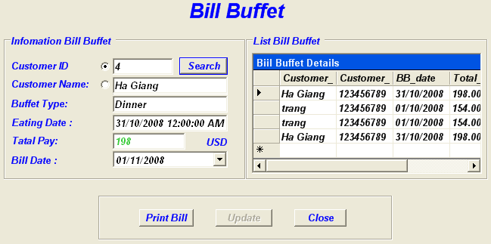

- Control on form:

No | Control | Type | Default Value | Description
1 | grp_Bill | GroupBox | Information Bill Buffet
2 | grp_ListBill | GroupBox | List Bill Buffet
3 | dbg_List | DataGrid | Load data
4 | lbl_title | Label | Bill Buffet
5 | lbl_Price | Label | Price
6 | lbl_VND | Label | VND
7 | lbl_FoodID | Label | Food ID
8 | lbl_BuffetID | Label | Buffet Booking ID
9 | lbl_Billdate | Label | Bill Date
10 | lbl_Price1 | Label | Null
11 | lbl_FoodID1 | Label | Null
12 | lbl_BuffetID1 | Label | Null
13 | lbl_Billdate1 | Label | Null
14 | btn_Print | Button | Print Bill
15 | btn_Close | Button | Close
16 | btn_Save | Button | Save

- Form name: Login
- Description: Login
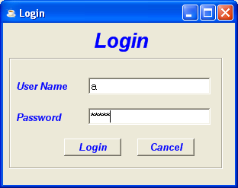

- Control on form:

No | Control | Type | Default Value | Description
1 | grp_Login | GroupBox | Null
2 | lbl_login | Label | Login
3 | lbi_username | Label | UserName
4 | lbl_password | Label | Password
5 | txt_user | TextBox | Null
6 | txt_pass | TextBox | Null
7 | btn_login | Button | Login
8 | btn_cancel | Button | Cancel

- Form name: Customer
- Description: Add New Customer
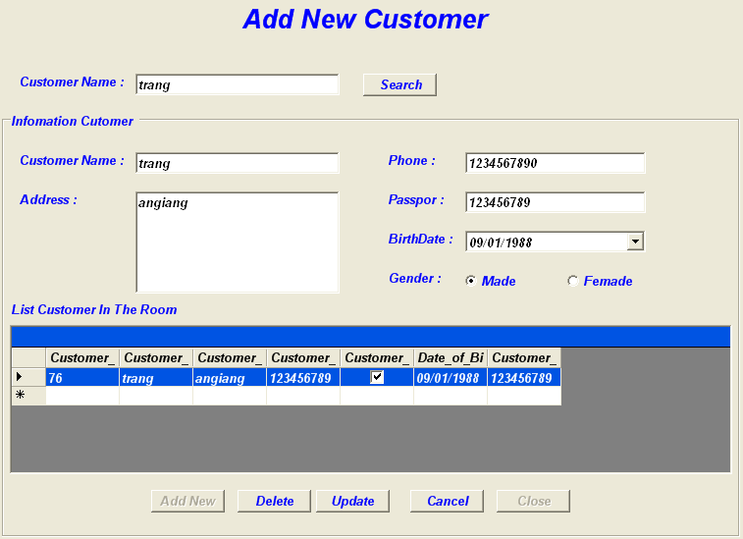

- Control on form:

No | Control | Type | Default Value | Description
1 | grp_InfomationCustomer | GroupBox | Information Customer
2 | dbg_ListCustomerInTheRoom | DataGrid
3 | lbl_TitleAddNewCustomer | Label | Add New Customer
4 | lbl_SearchCustomerName | Label | Customer Name
5 | lbl_CustomerName | Label | Customer Name
6 | lbl_Addess | Label | Addess
7 | lbl_ListCustomerInTheRoom | Label | List Customer In The Room
8 | lbl_Phone | Label | Phone
9 | lbl_Passpor | Label | Passpor
10 | lbl_birthDate | Label | Birth Date
11 | lbl_Gender | Label | Gender
12 | txt_SearchCustomerName | TextBox | Null
13 | txt_CustomerName | TextBox | Null
14 | txt_Address | TextBox | Null
15 | txt_Phone | TextBox | Null
16 | txt_Passpor | TextBox | Null
17 | dtp_BirthDate | DateTimePicker | Birth Date | dd/MM/yyyy
18 | rad_Made | RadioButton | Made(Checked)
20 | rad_Femade | RadioButton | Femade
21 | btn_Search | Button | Search
22 | btn_Addnew | Button | Add New
23 | btn_Delete | Button | Delete
24 | btn_Update | Button | Update
25 | btn_Cancel | Button | Cancel
26 | btn_Close | Button | Close

 | Prepared By (Student) | Approved By (Teacher)
Date:25/09/2008 | Trang | Tran Thi Hong An

